Machine learning

Project: Feature Engineering

20BIS015

Report:

Minmax scaler:

MinMaxScaler rescales the data set such that all feature values are in the range [0, 1] as shown in the right panel below. However, this scaling compresses all inliers into the narrow range [0, 0.005] for the transformed average house occupancy

Here we are scaling age column and fare column

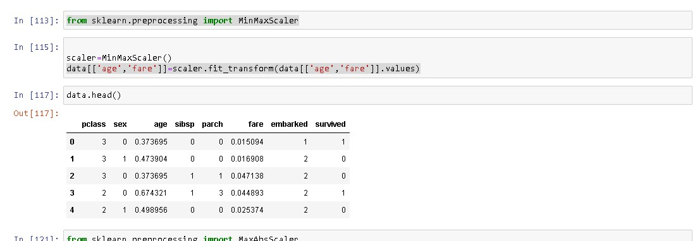

Maxabsscaler:

MaxAbsScaler is similar to MinMaxScaler except that the values are mapped across several ranges depending on whether negative OR positive values are present. If only positive values are present, the range is [0, 1]. If only negative values are present, the range is [-1, 0].

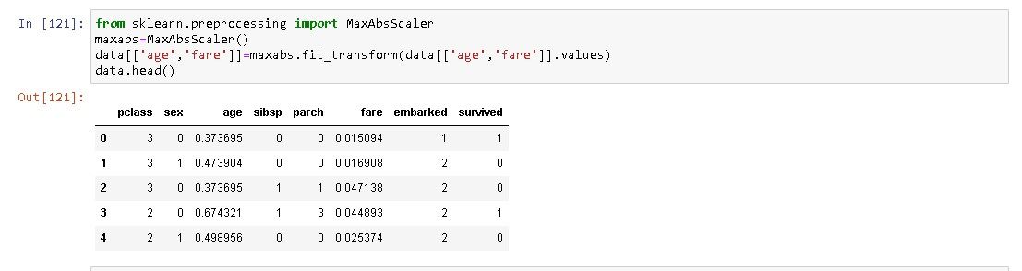

Power transformer:

PowerTransformer applies a power transformation to each feature to make the data more Gaussian-like in order to stabilize variance and minimize skewness. Currently the Yeo-Johnson and Box-Cox transforms are supported and the optimal scaling factor is determined via maximum likelihood estimation in both methods.

